|  |  |  |  |
| --- | --- | --- | --- |
| Artifact ID:  CD-001 | Artifact Title:  Brainstorm Notes | |  |
| Revision:  1.0 | Revision Date:  8 OCT 2019 | |
| Prepared by:  Daniel Sharp | | Checked by:  Autumn Twitchell |
| Purpose:  Capture our brainstorming session | | |

# Revision History

|  |  |  |  |
| --- | --- | --- | --- |
| Revision: | Revised by: | Checked by: | Date: |
| 1.0 | Daniel Sharp | Jesse Krage | 8 OCT 2019 |
| 1.1 | Jesse Krage | Autumn Twitchell | 16 OCT 2019 |

# References

|  |  |  |
| --- | --- | --- |
| Artifact ID: | Revision: | Title: |
| CD-002 | 1.0 | User Interface Ideas |
| CD-003 | 1.0 | User Interface Diagram Details |

# Notes

**Processor Ideas**

* On-board Chromebook (minimal computer)
* What if everything was off-boarded? (Bluetooth or cloud)
* Type of processors:

1. Raspberry Pi 3 Mod B+
2. Pine H64 Mod B
3. La Frite

* Could run image processing
* Uses amount of thruput to measure position
* Track multiple drones?
* Do more with less info
* Cloud based saves previous settings
* Saves all previous uses
* Default setting
* Can we get a visual of what the drone is looking at?

For sure:

* Default settings and previous 5-10 settings
* Raspberry Pi

Build on:

* 3 way access(Bluetooth, wifi(network), and onboard)
* Uses amount of throughput to measure position
* Could run image processing

Configure RPi as Local Host

<http://www.intellamech.com/RaspberryPi-projects/reference-docs/RaspberryPi3WiFiAccessPoint.pdf>

Control Software

Predictive Control System (in field of view/FOV, and reacquisition)

-pro-active

Point it at location of drone

-reactive

-most re

Scanning System (reacquisition)

Provide visual feedback that target is in FOV (GUI)

Control through arrows (GUI)

**Positioner/Mount Ideas**

* Octopus powered
* Human powered
* What if the dish was big enough to cover the Area of Operation
* Electronically controlled beam direction
* Gimbal
* Magnetometer & GPS to know location of positioner
* Sensors (internal gyroscope) that can tell the processor how far it is from level
* Adapter for gimbal and camera or permanent camera
* Ropes and pulleys
* Self-level tripod if askew - like on a boat
* Sensors in the feet of tripod to help
* Accounts for movement of the radar system
* Put positioner on a track so that the wires can stay in the middle and not be wrapped around the system

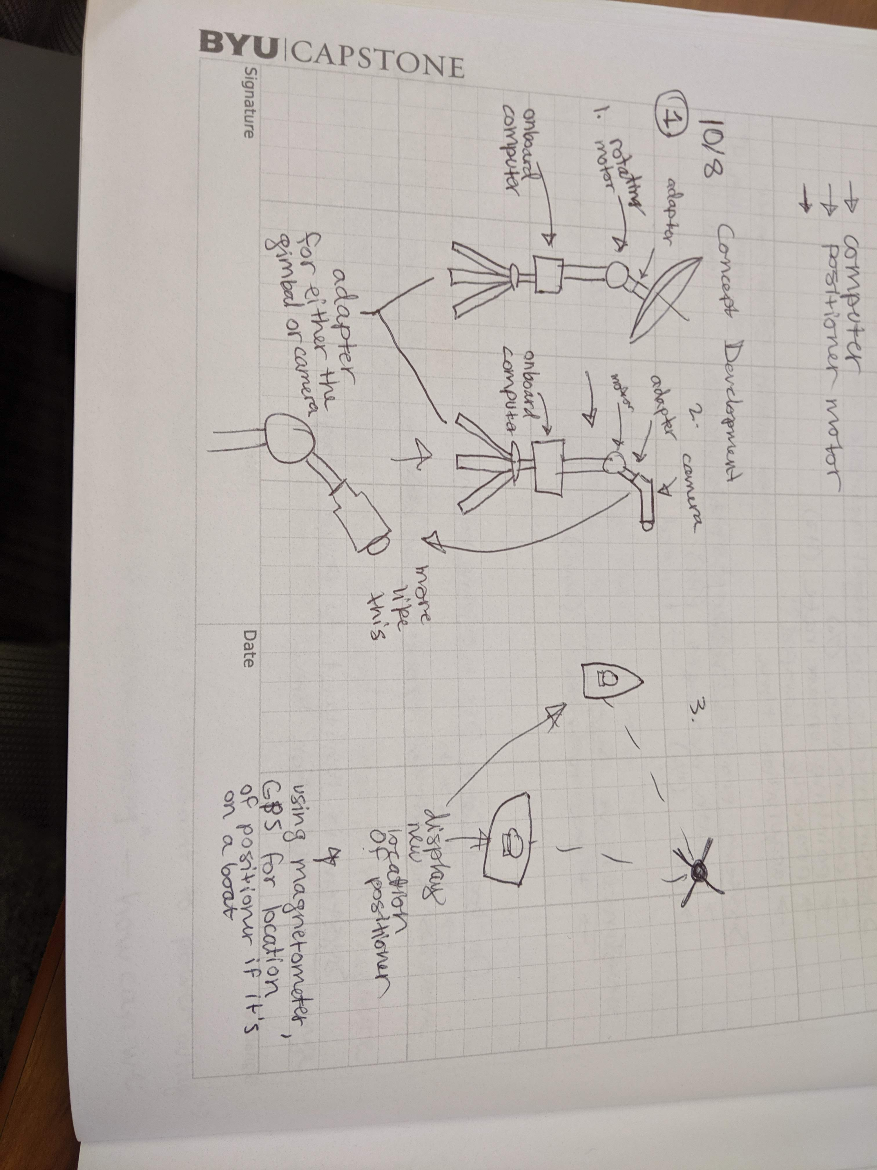

Positioner drawings

**GUI**

* App with QR code
* User is prompted through physical setup of the entire radar
* Has hidden Easter eggs
* Anticipates next user input
* Ads for other IMSAR products
* Useful in setting up other IMSAR products
* Operable with one button
* Controls the drone
* Alexa controlled
* Streams live footage from drone
* Pink